First Response to Question 1:
According to reviewer 1's suggestion, we re-estimated the divergent time using a demographic modeling including hybridization and found that divergent time based on this modelling is consistent to that based on a demographic modeling without hybridization (Fig. 3b)…. we confirmed the possible hybridization of the mallard duck and the spot-billed duck through genetic structure analysis and found no evidence to support that there was hybridization in these tested mallard duck and spot-billed duck
Further Question on Question 1:
Because the description of the method (line 551-) is unclear, and the Fig 3b is not legible, I cannot make an explicit comment. However, it seems like there is no strong support for the absence of gene flow between Mallard and spot-billed duck. First, in dadi analysis, it seems like simply a power issue to distinguish the two models. In general, dadi provides almost indistinguishable 2d-SFS for 2 scenarios - one with recent divergence with no gene flow and the other with relatively ancient divergence with recent gene flow. In any case, there is no description about how the likelihood of the two models were compared (line 219-234), but I presume that the authors might have done some statistical tests. Regardless of the test result, even if the two models (with or without gene flow) are equally likely, this cannot be taken as an evidence for the absence of gene flow. All we can tell from this analysis is that the two models are equally likely (or a test statistics does not have sufficient power to distinguish the two). Second, the STRUCTURE result cannot be used as an evidence for the absence of gene flow as all it does is to cluster populations based on genetic similarity (ancestry proportion Q).

Reply: Reviewer is correct. In fact, We have considered the confounding effect between gene flow and divergence time when we repeat and modified my dadi analysis follow the reviewer 1’s advice after the first comment. But the previous explanation may not clear. The detail description of the method has been supplied in the Additional Notes which is referred as additional file 6 that is not clearly stated in previous submission and has been modified in this submission. Really apologize for the trouble caused. And we have made the Fig. 3b more legible. Here, we would like to illustrate it more clearly to address that the simulation result of model with geneflow could be an evidence of shorter divergence time between mallard and spot-billed than the one between wild and domestic. Indeed, dadi software cannot distinguish short-divergence with no migration from long divergence with high-migration. In our second simulations (with migration), estimate Ts does increased, when compared with first model (without migration), due to introducing migration. But the Ts still convergent into two peaks, this could be regard as: even dadi have difficult to distinguish the two scenarios, then performed simulations under both situations. We can find that Ts convergent into two peaks, that higher estimated Ts with higher migration rate whereas lower estimated Ts with lower estimated rate. i.e. under the two extremely simple models (to focus on the effect of Ts and migration parameters and in case of the simulations not converge due to other parameters), estimate Ts convergent into two peaks due to dadi cannot distinguish short-divergence with no migration from long divergence with high-migration. But both situations, estimated Ts between wild and domestic are higher than the one between mallard duck and spot-billed. In addition, we provided the distribution of likelihood for each kind of simulation. We found that there is no obvious different likelihood between the two models. And we thought the likelihood may only provide a rough evaluation to simulation because parameters in dadi are correlated, not as standard likelihood theory required: all variants should be independent. From the Response Fig. S1, we can see that likelihoods between model with migration and without migration don’t show significant difference.
Response Fig. S1. Likelihood Distribution from bootstrap results. Distribution of likelihood produced by using model with migration/without migration are shown as blue picture/green picture, respectively. Simulation of divergence between mallard and spot-billed (M and SP), mallard and domestic (M and D), spot-billed and domestic (SP and D) are performed by both models each.

Moreover, we note that the genomic similarity between mallard and spot-billed is higher than it in wild vs domestic pairs (mean F_{ST}: 0.0637, 0.2099 respectively), and the “homogeneity” of this similarity in autosomes is also higher in mallard vs spot-billed pair (std F_{ST}:0.0349), than its in wild vs domestic pairs (std F_{ST}:0.0465) (Fig. 5b). It seems an evidence of a more recent divergence time between mallard and spot-billed. This more similarity and more homogeneity property maybe also caused by extensive geneflow. If so, those genomic part that show more homogeneity between mallard and spot-billed may have more gene flow evidence than those region that show more “heterogeneous” part. According to recent research on introgression issue in chimpanzee (Mare et al. science 2016), the chance of derived alleles being introduced through gene flow increases with the frequency in the donor population. Gene flow should introduce into receptor populations at low frequencies. So, we would expect that higher ΔDAF (or lower in negative) in genomic background (more homogeneity between mallard and spot-billed) than those genomic differentiation regions, if gene flow played a major factor in this genomic similarity. Whereas the mean value of the ΔDAF (absolute ΔDAF) didn’t show significant difference between high differentiation regions (Response Table S1).
Response Table S1. Averaged all ΔDAF (absolute ΔDAF) of windows inside/outside high differentiation regions.
Mean value across SNPs | high differentiation regions | Genomic background
absolute ΔDAF | 0.0385672 | 0.03672404
ΔDAF | 0.0370516 | 0.03497989

Similarly, we stratified the divergence value (F_{ST}, dxy) of all windows by mean value of ΔDAF (absolute ΔDAF) in this window. We may expect lower divergence value in these regions with higher ΔDAF (absolute ΔDAF) as it represented more probability of introgression. However, both
Response Fig. S2. Mean F_{ST,} dxy of windows across whole genome stratified by ΔDAF (absolute ΔDAF) between mallard and spot-billed population. Negative ΔDAF indicate derived allele frequency of spot-billed is higher than the one in mallard. Few windows with negative ΔDAF indicate that almost all windows’ mean derived allele frequency are higher in mallard population than spot-billed population. “M”,”SP” and ”D” indicate mallard, spot-billed and domestic duck, respectively.

F_{ST} and dxy increased with the ΔDAF (Response Fig. S2). These observations are consistent with recent research that gene flow is not a major factor in the formation of genomic islands in Darwin’s finches (Fan et al. genome research. 2017). In contrast, F_{TS} between mallard (or spot-billed) and domestic population did decrease in higher absolute ΔDAF bins (when ΔDAF = 0.4-0.8), which imply an evidence of introgression effect between wild duck and domestic ducks (Response Fig. S3). This is consistent with the genetic structure analysis (Fig. 2 d; Additional file 26) and D-statistics (-0.2972960214692928; jackknife std: 0.4189029307317864). Since further analysis on this issue may involve other complex issue such as the formation of the high
Response Fig. S3. F_{ST} between domestic and wild duck populations decreased due to introgression. Blue line (corresponding to purple line in Response Fig. S2) indicated no evidence of introgression between mallard and spot-billed, in contrast to red and purple lines. “M”, ”SP” and ”D” indicate mallard, spot-billed and domestic duck, respectively.

differentiation regions. Here we use other strategy, ABBA-BABA test, to characterized the gene flow effect on the phylogenetic tree reconstruction, by using Muscovy duck as outgroup.
Assume that mallard, spot-billed, domestic duck is P1, P2, P2 respectively. Among the three genealogical tree which could produce two derived allele “B” in two population with one mutation events (Response Fig. S4). The first situation would produce the largest number of BBAA pattern sites, whereas other would produce largest number of BABA or ABBA pattern sites, respectively (Green et al. Science 2010). And we found the number of BBAA sites (117315) is significantly higher than that of two other patterns (ABBA: 70662, BABA 52500). This analysis confirmed that mallard duck and spot-billed has a closer genetic relationship.
Number of sites supporting different tree:
BBAA:117315(49%) BABA:70662(29%) ABBA:52500 (22%)
M SP D
M D SP
SP D M
Response Fig. S4. Comparing BBAA, ABBA and BABA counts provides a test for whether domestic duck lineage are an outgroup to mallard and spot-billed ducks.“M”,”SP” and ”D” indicate mallard, spot-billed and domestic duck, respectively.

To further investigate whether this excess of derived allele sharing was caused by highly hybridization between mallard duck and spot-billed duck populations. We also stratified the number of BBAA (ABBA, BABA) sites by the derived allele frequency difference (ΔDAF) bins between mallard duck and spot-billed duck populations (spot-billed and domestic, mallard and domestic, respectively) (Response Fig. S5).
Response Fig. S5. Absent evidence of introgression between mallard duck and spot-billed duck population. BBAA rate were measured by the BBAA counts divided by number of sites that derived allele present in mallard or spot-billed population in each bins (ABBA, BABA etc.). the red dash line is corresponding right y-axis. “M”,”SP” and ”D” indicate mallard, spot-billed and domestic duck, respectively.

The most majority proportion of BBAA (ABBA, BABA) sites were distributed in low ΔDAF bins, imply phylogeny is the major reason for excess of BBAA sites rather than introgression. As the majority number of SNPs (polymorphic in compared two populations. i.e. Polymorphic sites in SP and D, M and D, M and SP for ABBA, BABA, BBAA, respectively) distributed at lower ΔDAF bins. We further test the distribution of proportion of the BBAA sites among all SNPs. if the introgression exists between M and SP (M and D, SP and D), we may expect the proportion of BBAA (BABA, ABBA) sites would increase with the absolute ΔDAF. However. we found that only BABA, ABBA sites indicate the evidence of introgression, whereas the proportion of BBAA only showed very little difference among ΔDAF bins. This indicate that the derived allele sharing between wild and domestic population is partly due to the introgression, whereas the derived allele sharing between mallard and spot-billed lacking this evidence. And the introgression evidence between domestic and wild population is also observed in genetic structure analysis (Fig. 2 d; Additional file 26) and D-statistics (-0.2972960214692928; jackknife std: 0.4189029307317864).

Response to Question 2:
> To make this approach as effective as possible, we made a lot of control to optimize, for example, SNP depth, MQ value, window size (according LD decay and SNP number in each tested window sizes. Data not shown), pooled populations to lessen the genetic drift effect causing by limited effective population size.
Further question on question 2:
My concern in my first review is that "However, there are many processes creating such a pattern other than selective sweeps, and such a simple approach has been criticized (e.g., Cruickshank and Hahn 2014)". Therefore no matter how stringent SNP filtering one might use, underlying evolutionary mechanisms in the formation of 'outliers' (sweep, drift, recombination, or any kinds of alternative processes) cannot be distinguished.

In addition to the weaknesses in analyses, I pointed out in my first review that "hypotheses were not clearly articulated, and presentation of results and discussion does not meet journal standard". The reviewer 2 also raised a similar concern. I tried to review this revised manuscript very carefully to avoid misinterpretation, but it is still very difficult to understand what was actually done, what was tested, and how results were interpreted objectively. Therefore, if the authors wish to submit this manuscript again as a research paper, I highly recommend to use some service to improve writing and presentation of data.
Reply: Limited by many factors, we used very conserved strategy, may not the very advance in methods. However, here we think our result is still reliable: because this method has been succeed applied in previous reports (such as Erik et al. Nature. 2013, doi:10.1038/nature11837; Nima et al. Mol Evol. 2017, DOI: 10.1111/mec.14494 Kayla et al. PLOS Genetics. 2017, doi:10.1371/journal.pgen.1006539). So, we think this method could provide a certain reference value, even it weakness. Furthermore, following the reviewer’s advance, we perform the statistic test on this 'outlier' approaches using 4 times of zF_{ST} and zHp to define selective region, 4 times represent the extreme ends of the distribution of z F_{ST} and zHp, and P-value is less than 0.05, zF_{ST} (P(zF_{ST} >=4) = 0.00548), zHp(P(zHp<=−4) = 0.00322).
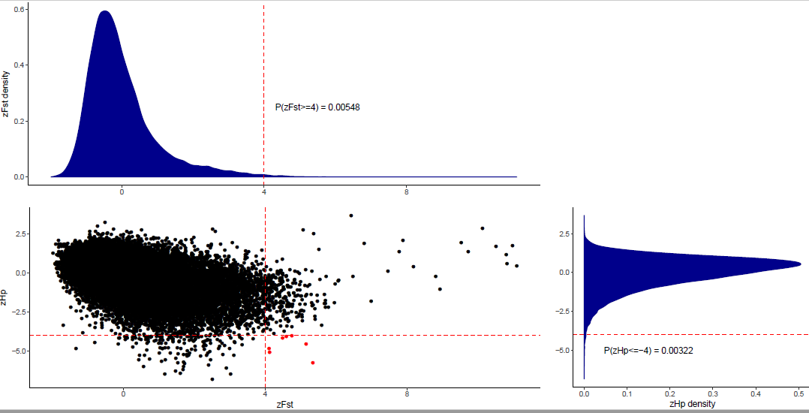
Response Fig. S6. Distribution of zF_{ST} and zHp.

Question 3:
Specific comments:
Line 32: 'The wild lineage adapted to climate change,…'

No solid evidence presented to support this statement.
Reply: Thanks for advice. We have changed the improper statement, please refer to our new manuscript.

Question 4:
Line 106: Additional file 6 is missing. I cannot evaluate the method for TE annotation.
Reply: As mentioned above, Additional file 6 is Additional notes. We are very sorry for this unclear statement and has modified it in this submission.

Question 5:

Line 109-126:
What is the basis for the significance (Line 109)? The term 'significantly' is usually used when it is 'statistically' significant. More importantly, TE annotation and quantification are notoriously difficult due to its repetitive nature. In other words, sequencing platforms, genome assembly pipelines, and TE annotation pipelines all affect the number and diversity of TEs identified in the final assembled genomes, and it is very difficult to make a fair comparisons between studies. Without any statistical support and rigorous control in methodological differences, one cannot conclude that the observed 'differences' reflects biological differences.
Reply: Thanks for advice. We used the same sequencing platform and de novo assembly software with Beijing Duck to get the two wild genomes. And use the same software and database to do the TE annotation to avoid the influence of these factors. And we have removed improper adjective words in our manuscript. We also deleted some of our states lacking solid evidence. Please refer to our revised manuscript for details.

Question 6:
The same is true in the CR1 analysis. As I pointed out in my previous review (Question 14), one cannot infer the direction of TE increase/decrease without ancestral state of TE abundance. Based on the Abstract, the lineage leading to the domesticated Beijing duck likely has diverged from the common ancestor of Mallard and spotted-billed duck. Whether CR1 has expanded in the (Mallard-Spot) lineage or decreased in the (Beijing) lineage cannot be determined without using a common ancestor of these lineages.
Reply: Same as the reply above.

Question 7:
Line 127-131:
Additional note 3.3 should be referred here. Apart from this, the authors should eliminate a possibility where higher TE content and the larger number of SDs in Mallard and spotted-billed ducks are due to assembly artifacts by not assembling two alleles of the same loci together. This is particularly problematic when a sequenced genome is highly heterozygous. Commonly used genome assemblers tend to struggle with diploid organisms with high heterozygosity and may put sequence reads from two alleles separate. It is a little suspicious as to why the two species under study coincidentally have higher TE and SD contents (and the larger number of predicted genes [line 132-]).

Maybe one can compare the proportion of reads in SD regions (eg., 1-to-1-to-2-to-2 in chicken-zebrafinch-Mallard-Spot) and those in regions of 1-to-1-to-1-to-1 orthologous regions. If they are genuine SDs, the proportion of reads should be equal between these two groups. In contrast, if putative SD regions have lower proportion of reads, then genome mis-assembly is likely. In addition, it is even better to confirm TE, SD expansions at a subset of loci by using qPCR, Southern blot, or other independent means.
Reply: We used the same methods and parameter settings to detect SD regions within those genome assemblies. This lay down the foundation for a fair comparison. The repetitive sequences were masked prior to our analysis, so that the result won’t affect by TE elements. To further rule out the possibility that more SD regions we detected in the wild ducks were due to mis-assembly caused by high heterozygosity, we compared the coverage depth of SD regions (Response Fig. S7-8). The distribution of coverage depth showed little difference, indicating most of our detected SD regions are true.
However, after a serious discussion, we considered this section as a peripheral branch of our main story. To make our revised manuscript more concise and dedicated, we deleted it.

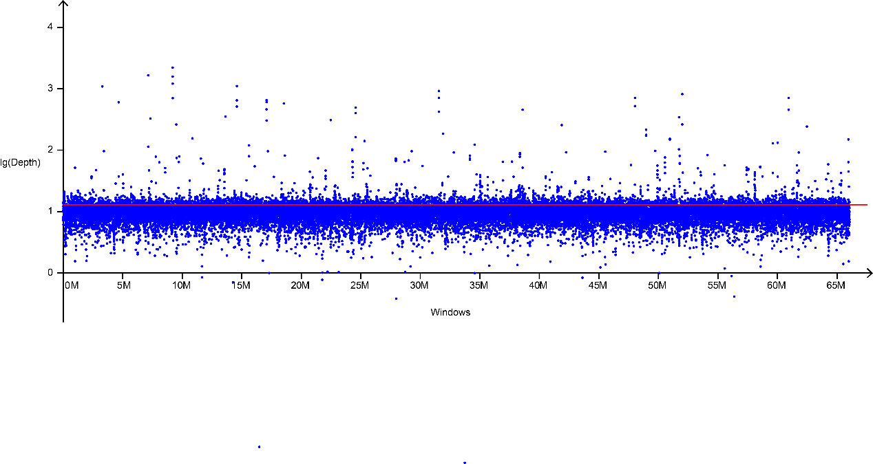
Response Fig. S7. Sequence depth of SD regions of Spot-billed
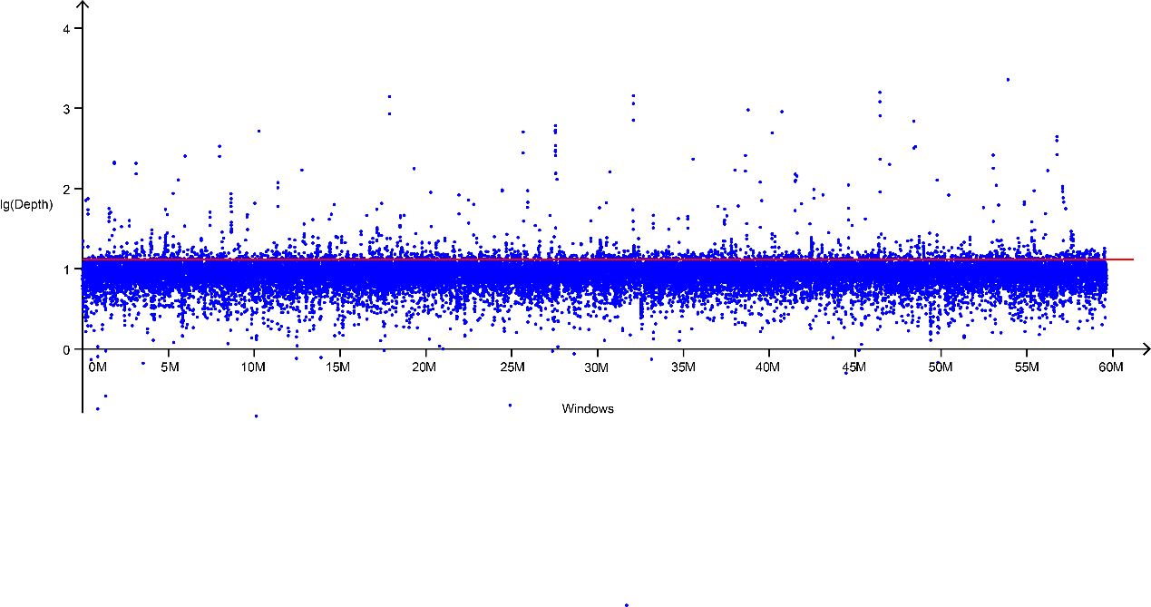
Response Fig. S8. Sequence depth of SD regions of Mallard

Question 8:
Line 152-158:
This is a typical example of 'evolutionary spandrel (http://rspb.royalsocietypublishing.org/content/205/1161/581)', where one would interpret observed patterns as adaptive consequences without rigorous analysis. Cherry-picking 2 out of 25 gene families and interpreting in this way is not acceptable. How should one interpret the remaining 23 gene families then? Whether or not gene expansion has taken place in the two wild duck lineages, it is too far fetched to interpret this as a result of adaptation.
Reply: We changed our way to present our analysis results. We performed GO enrichment analysis of those genes from expanded gene families, depicted the most enriched terms that they are involved in. We also replace the content of Table S9 with the enrichment analysis result. Please see our main text as well as additional file for details. Replace Table S9 with ‘enrich_GO_P.xlsx’, using title: Table S9: Over represented GO terms (pvalue  0.001) of wild duck expanded gene families.

Question 9:
Line159-178:
It is not readily visible in this Result paragraph, but all the reads of the same and different species were mapped onto the reference genome of Beijing duck, correct? If so, how is this phylogenetic relationship reflected in the number of private and shared SNPs among the three lineages? It is counter-intuitive that domesticated animals have the larger number of SNPs than wild counterpart.
Reply: It is true that wild duck populations have the larger number of SNPs than domesticated ducks. The related statement was presented in line 153-154. In fact, most of our analysis used the SNP sets that all the reads of the individuals were mapped to the reference genome of Beijing duck, meanwhile, some analyses use the wild duck assemble for comparison (e.g. Additional file 24).

Question 10:
Line 179:
Similar to the above comment, I am wondering whether the same SNP sets were used in these dadi and PSMC analyses. If so, how does the mapping bias affect the results? Since the Mallard and spot-billed reference genomes are available, can one obtain the same results when SNPs are called by using different reference genomes?
Reply: As mentioned above, we have compared the analyses using different assembles, some were presented in manuscript and some not, and we found it make only tiny difference. Here we presented the PSMC analyses using spot-billed duck genome as reference. We can see it made no difference with the same analyses using reference genome of Beijing duck. Moreover, we would like to address that the ∂a∂i and PSMC simulations that rely on different data sets and theory reconstructed the perfect matched demographic history further support the robustness of our inference.
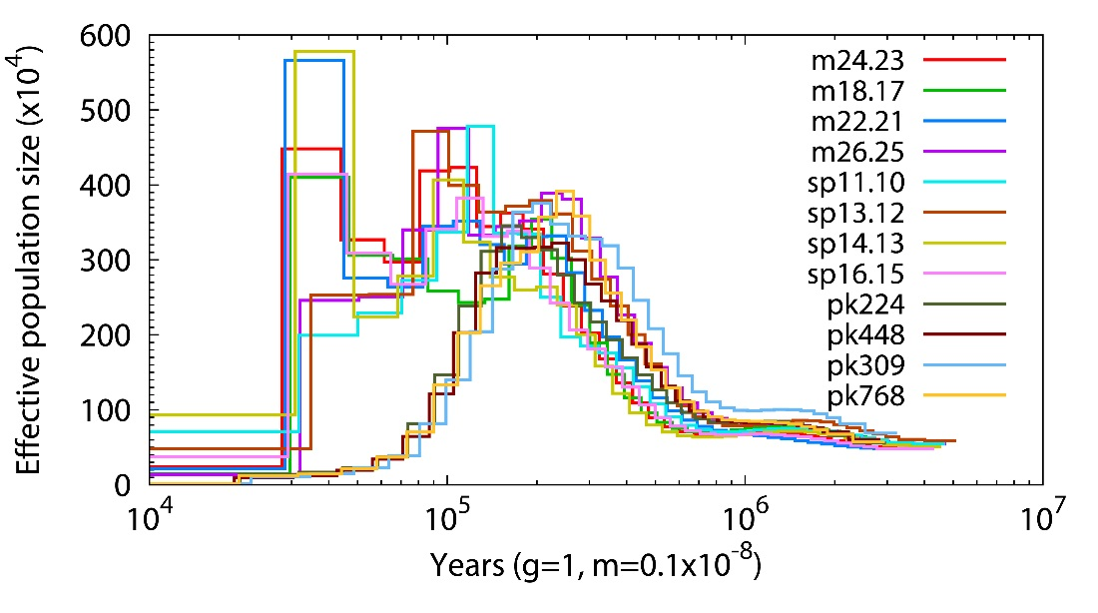
Response Fig. S9. PSMC analyses. “mxx” indicate mallard. “pkxx” indicate Beijing duck. “spxx” indicate spot-billed duck.

Question 11:
Line 232:
Fig 3b is still not legible, and it is impossible to evaluate the result.
Reply: As mentioned above, we have made the Fig. 3b more legible.

Question 12:
Line 256-:
As I raised my concern in my previous comment (question 15), what are the statistical basis for choosing 4 and 1.5 standard deviations? Is it based on some randomization test to obtain confidence intervals? And what are the population genetic statistics used for defining differentiation islands? Once again, 'outliers' can result from many other processes in addition to sweeps, and thus it is premature to call them as sweep regions.

Line 364:
Similar to my previous comment, what is the statistical basis for 4SD?

Reply: Same as the reply of question 2.

